Assessment
Policy

PURPOSE
Assessment is integral to all teaching and learning. It is central to the PYP goal of thoughtfully and effectively guiding students through the 5 essential elements of learning: the acquisition of knowledge, understanding of concepts, mastering of skills, development of attitudes and decisions to take action. The prime objective of assessment in the PYP is to provide feedback on the learning process.

GUIDELINES
Assessment involves the gathering and analysis of information about student performance and is designed to inform practice. It identifies what students know, understand, can do and feel at different stages in the learning process. Students and teachers should be actively engaged in assessing the students’ progress.
Student learning is promoted through planning and refining the learning and teaching process to meet individual or group needs. Assessing the student’s prior knowledge and experience as well as monitoring their achievement during the teaching period will enable teachers to plan and refine their teaching accordingly.

The following diagram captures the assessing, recording and reporting process as Kunyung Primary School.

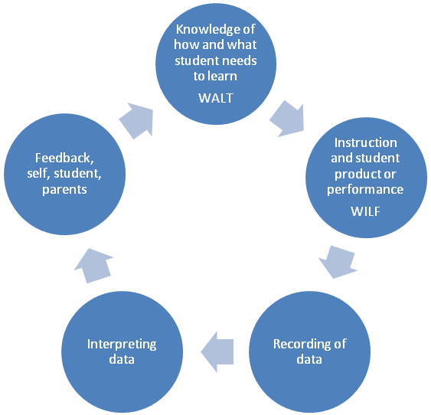

A well designed learning experience will provide data on students’ knowledge, skills and conceptual understanding, and is consequently a vehicle for summative and formative assessment.

- Formative assessment (assessment for learning) – is interwoven with learning and helps teachers and students find out what the students already know and can do identifies prior knowledge and misconceptions to inform planning for instruction
- Formative assessment (assessment as learning) informs daily planning for instruction and promotes learning by giving regular and frequent feedback. This helps learners to improve knowledge and understanding, to foster enthusiasm for learning, to engage in thoughtful reflection, to develop the capacity for self assessment and to recognise the criteria for success. Increased use of formative assessment particularly helps student who are low achievers to make significant improvements in their understanding.
- Summative assessment (assessment of learning) gives teachers and students a clear insight into students’ understanding. Summative assessment is the culmination of the teaching and learning process, and gives the students opportunities to demonstrate what has been learned. It measures understanding of the central idea and promotes students towards action.

To promote effective assessment teachers:-
- Facilitate an inclusive environment conducive to giving and receiving feedback in each learning space
- Follow essential agreements displayed about how the learning space will feel, look and sound
- Explicitly display WALT (We Are Learning To) and WILF (What I’m Looking For) to encourage daily reflective practice by students and teachers.
- Assess EVIDENCE (what the students can do, say, make or write) NOT make INFERENCES
- Collaboratively plan for assessment as part of the teaching and learning program
- Dialogue in PLTs / unit meetings focusing on evidence to identify what students are ready to learn (not what students cannot do)
- Clearly define student’s needs and adapt learning experiences accordingly
- Plan in response to student and teacher inquiries
- Assess, but not rank, the learner profiles and attitudes
- Make explicit in advance the purpose of the assessment product, performance or process and the criteria for success
- Plan a variety of assessment and evaluation strategies and tools to allow students to demonstrate the full range of their learning including how they are feeling
- Collect qualitative and quantitative data
- Assist students to meet the required standards through regular descriptive feedback
- Provide students with opportunities, examples and models to learn how to assess their own work, set goals for improvement and achieve excellence
- Provide criteria or tools to facilitate meaningful peer assessment
- Provide assessment strategies that accommodate the needs of all students (including those with individual learning plans) and the needs of students who are learning English as a second language
- Reflect on UOI to prepare for future inquiries
- Collaboratively moderate assessment evidence in level teams and PLTs
- Produce evidence that can be reported and understood by the student, parent, teacher and used by the school to evaluate programs

Effective assessment allows students to:-
- Base their learning on real life experiences that can lead to further inquiries
- Use their prior knowledge to build on and guide the inquiry process
- Demonstrate and share their learning – knowledge, understanding, concepts, attitudes, skills and actions
- Employ a variety of learning styles to express their learning
- Analyse their learning and understand what needs to improve
- Set challenging but reasonable and attainable goals
- Apply their learning, not merely recall facts
- Express their points of view and understanding
- Know and understand in advance the criteria for producing a quality product or performance
- Critically and actively promote self and peer reflection
Effective assessment allows parents to:-
- See evidence of student learning and development
- Develop an understanding of the student’s progress
- Provide opportunities to support and celebrate student learning

WHAT IS ASSESSED
Knowledge, understandings and skills in line with Departmental policy and IB requirements including the following areas:
- Language – English and LOTE (French)
- Mathematics
- Visual Art
- Performing Arts and Music
- Physical Education
- Science, Humanities, Health – specifically through the Program of Inquiry
- Transdisciplinary Skills - Thinking Skills, Social Skills, Communication Skills, Self Management Skills, Research Skills
- Learner Profiles / Attitudes

HOW WILL WE ASSESS?
- Teachers will utilise the following six core assessment strategies.

Strategies | Description | Tools
Observations | Focus in a variety of situations | Rubrics, Checklists, anecdotal records, Continuums
Performance assessments | Assessed on goal directed tasks with established criteria.  Against agreed standard/benchmark. | Rubrics, exemplars, anecdotal records, student reflections, learning journals, art pieces, performances, continuums, videos
Process – focused | Transdisciplinary skills observed and noted down | Checklists, anecdotal records, continuums, rubrics
Selected responses | On a single occasion – one-dimensional exercises | Exemplars, checklists, continuums, Test, quiz, short answer response, multiple choice, true / false
Questioning | Open and closed questions | Conferences
Open – ended tasks | Students presented with issue/problem/ stimulus and asked to communicate an original response. | Rubrics, exemplars, anecdotal records, continuums, written answers, drawings, diagrams, samples of work, art pieces,
Summative assessment of English and Maths skills for reporting purposes will occur using On demand testing, English On line, Early years Numeracy Interview, Auditory Processing and other ways as directed by Departmental Policy and IB requirements.
Record Keeping
- All teachers are responsible for keeping evidence of information gathered from assessment procedures.
- Semester Reports are stored cumulatively in student files
Student portfolios
- Student portfolios provide a picture of each student’s growth and development over a period of time both as individual and as group learners. It enables students to reflect with teachers, parents and peers in order to identify their strengths and growth as well as areas for improvement, and then to set individual goals and establish teaching and learning plans.
- An essential agreement on Student Portfolios further informs requirements at this school (see Appendix 1 for Essential Agreement)
REPORTING
Reporting will be conducted in line with Departmental policy and IB requirements
How we communicate information about assessment
Conferences:-
Teacher – Student
Frequent feedback from teacher to student enables reflection and further refinement of skills and understandings supporting student learning and teacher planning.
Teacher – parent(s)
These conferences occur formally at the start of each year and then as needed throughout the year. They are designed to give information about the student’s progress and needs, answer parent questions and inform parents about the school’s programme. They provide parents with the opportunity to provide information about the cultural context of the student’s learning.
Student-led
The student is responsible for leading the conference using different learning situations and work samples that have been previously discussed and prepared with the teacher. The student identifies strengths and areas for improvement.
Three-way
Involve the student discussing their learning and understanding with their parents and teacher, who are responsible for supporting the student through this process. Students reflect upon work samples, products and performances they have chosen with guidance from their teacher. Student, teacher and parents collaborate to establish and identify student’s strengths and areas for improvement. This may lead to the setting of new goals, with all determining how they can support the achievement of these goals. The teacher takes notes at these conferences and can use the notes to form part of the written report.
The Written Report
Determination of grading levels for formal reporting purposes will reflect student performances on summative assessment tasks. Student grades will reflect their most consistent level of achievement, usually their most recent level of achievement at the time of reporting. Teachers work collaboratively to determine achievement levels and to establish exemplars.

Teacher - Student | Teacher - parent | Student-led | Three-way | The Written Report | Other opportunities
Level 1 – 4 Regularly throughout the year | Level 1 – 4  February  ‘Get to Know you Conferences’.  Parent Information sessions throughout the year.  At Teacher or Parent request as needed throughout the year. | Level 1 – 4  Student led conference at end of each unit of inquiry | Level 1 – 4  Student, teacher and parents following written report in June | Level 1 – 4  Written Report in June and December | Student support group meetings for students with individual learning plans.  Homework and school work taken home  Student Portfolios taken home at the end of semester 1 and 2
The Exhibition
Following authorization as an IB World school students in the final year of the PYP will participate in a culminating project, the PYP Exhibition.

Evaluation:
The School Council review its policies every four years to ensure the needs of the School Community are met. The review process will be informed by any new knowledge to hand and feedback from all stakeholders. Any common or recurring issues will be addressed and information provided to the school through the parent opinion survey will be taken into account.

This whole school assessment policy addresses how information is recruited, analysed, used and stored in relation to student learning.

Kunyung Primary School has developed this Assessment Policy in collaboration with staff, parents and the school community.

Ratified by School Council (date):

Year for Review

